37.58: a) 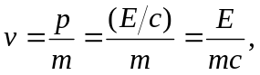 where the atom and the photon have the same magnitude of momentum, 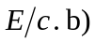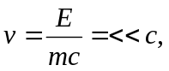 so 